**OCP GUIDE AT A GLANCE:**

**OPEN RECRUITMENT**

**SUPPLEMENTAL RESOURCE GUIDE**

TABLE OF CONTENTS

iNTERVIEW cONFIRMATION tEMPLATES 3-6

IN PERSON INTERVIEW CONFIRMATION 3

VIRTUAL INTERVIEW (ZOOM, SKYPE, ETC.) 4

SECOND INTERVIEW/ASSESSMENT CONFIRMATION 5

ATTEMPTING TO REACH CANDIDATE FOLLOW UP EMAIL 6

RECRUITMENT ADVISORY COMMITTEE (RAC) MATERIALS 7-11

BINDER/FOLDER COVER 7

SCHEDULE/TABLE OF CONTENTS 8

OPTIONAL CANDIDATE RANKING SHEET 9

RAC EMAIL 10

INTERVIEW QUESTIONS TEMPLATE 11

Sub Guides 12-18

PEOPLE ADMIN (PA) GUEST USER ACCESS 12

PULLING APPLICATIONS VIA GUEST USER ACCESS 13

REFERENCE CHECK TEMPLATE 14

INTERVIEW QUESTION BANK 15-18

GLOSSARY (COMING SOON ☺) 19

**IN PERSON INTERVIEW CONFIRMATION**

SUBJECT: Interview Confirmation: POSITION – UC Davis – Requisition #

*Attachement:* Copy of the Position Description

Dear NAME:

Thank you for accepting the invitation to interview for the POSITION position, at the University of California, Davis, with DEPARTMENT.  This email confirms your interview scheduled for **INTERVIEW DATE**, **at 9: 00 a.m.** located in the INTERVIEW LOCATION on the UC Davis Campus. Please check in on the second floor with the receptionist, where you will be greeted and escorted to your interview.

Your interview with the panel is scheduled for  60 minutes in duration.  Panel members are:

* Panel member names and titles

For your reference, I have also attached a copy of the full position description. Please also take some time to review the UC Davis Principles of Community, located at <http://occr.ucdavis.edu/poc/>.

The closest parking structure provides the easiest visitor parking in proximity to interview location.  For directional assistance a campus map is available at <http://campusmap.ucdavis.edu/>.  It is recommended that you allow about ten minutes for the walk from the parking lot to the building.

If you have any questions, please feel free to contact me.

Sincerely,

SIGNATURE

**VIRTUAL INTERVIEW (ZOOM, SKYPE, ETC.)**

**SUBJECT**: Interview Confirmation: POSITION – UC Davis – Requisition #

*Attachment:* Copy of the Position Description, any additional relevant information

Dear NAME:

Thank you for accepting the invitation to interview for the POSITION position, at the University of California, Davis, with DEPARTMENT.  This email confirms your interview scheduled for **INTERVIEW DATE**, **at 9: 00 a.m. Pacific Standard Time**.  Pursuant to our telephone conversation, a Virtual solution brand (Skype, Zoom, etc.) interview has been arranged in order to provide a live virtual interview solution. The Skype ID is **SKYPE ID.**Please add it as a Skype contact.

In the event that there is a problem with the virtual interview using Skype, the Panel will continue the interview by phone. **Please confirm the best phone number for the day of your interview** and the Committee Chair will call you, if needed. **Please also provide your Skype ID, in order for me to inform the committee for reference**.

Your interview with the panel is scheduled for  60 minutes in duration.  Panel members are:

* Panel member names and titles

For your reference, I have also attached a copy of the full position description. Please also take some time to review the UC Davis Principles of Community, located at <http://occr.ucdavis.edu/poc/>.

If you have any questions, please feel free to contact me.

Sincerely,

SIGNATURE

**SECOND INTERVIEW/ASSESSMENT CONFIRMATION**

**SUBJECT**: Second Interview Confirmation: POSITION – UC Davis – Requisition #

*Attachment:* Any additional relevant information

Hello NAME,

Thank you for your continued interest in the POSITION position with DEPARTMENT. This email confirms your interview scheduled for **Date**, **at 2: 00 p.m., located in LOCATION** on the UC Davis Campus. Please check in with the CHECK IN DIRECTIONS, where you will be greeted and escorted to your interview.

Your interview is scheduled for a maximum of 1 hour & 45 minutes in duration.  An assessment will take place (ADD DETAILS IF NECESSARY/FITTING) and you will also be meeting with:

* Second round stakeholders

Please let me know if you have any questions.

Thank you,

SIGNATURE

**ATTEMPTING TO REACH CANDIDATE FOLLOW UP EMAIL**

**SUBJECT: Attempting to Reach Candidate**

Dear NAME:

I am reached out via phone call earlier today, but wanted to also follow up via email.

On behalf of UNIT, I would like to invite you to interview for the POSITION position (REQ # XXXXXXXX) at the University of California, Davis. If you are interested, you are invited to interview the week of INTERVIEW AVAILABILITY, either in person or via a virtual solution.

Please let me know as soon as possible regarding your interest and availability.  The best number to reach me is at BEST PHONE NUMBER or please feel free to reply to this email.

Thank you,

SIGNATURE

**UNIT NAME**

**University of California, Davis**

Selection Committee Package

**WORKING TITLE**

(PAYROLL TITLE, Req# XXXXXXX)

**Interview Dates:**

**INTERVIEW START DATE**

**&**

**INTERVIEW END DATE**

**Selection Committee:**

EXAMPLE (Chair)

RAC

**CONFIDENTIAL - Please return to the Chair after final interview**

**Table of Contents & Interview Schedule**

Interviews for the position of

**POSITION TITLE**

INTERVIEW DAY 1 (INTEVIEW LOCATION)

|  |  |  |
| --- | --- | --- |
| Committee Pre-Meeting | 9:00 a.m. – 9:30 a.m. |  |
| CANDIDATE 1 | 9:30 a.m. – 10:30 a.m. | Page/Tab/Pack 1 |
| Break | 10:30 a.m. – 12:30 p.m. |  |

INTERVIEW DAY 2 (INTEVIEW LOCATION)

|  |  |  |
| --- | --- | --- |
| CANDIDATE 2 | 12:30 p.m. – 1:30 p.m. | Page/Tab/Pack 2 |
| Break | 1:30 p.m. – 1:45 p.m. |  |
| CANDIDATE 3, 4, ETC. | 1:45 p.m. – 2:45 p.m. | Page/Tab/Pack 3 |

**CANDIDATE FORCED RANKING SYSTEM**

|  |
| --- |
|  |

|  |  |
| --- | --- |
| **1.** | **2.** |

|  |  |  |
| --- | --- | --- |
| **1.** | **2.** | **3.** |

|  |  |  |  |
| --- | --- | --- | --- |
| **1.** | **2.** | **3.** | **4** |

|  |  |  |  |  |
| --- | --- | --- | --- | --- |
| **1.** | **2.** | **3.** | **4.** | **5.** |

PANELIST_________________________

**(If there are more than 5 candidates, using a horizontal paper orientation is recommended)**

**SUBJECT: Selection Committee - POSITION - UC Davis - Requisition 0301#**

***Attachment:*** Copy of the Position Description, candidate application materials, interview questions and the interview schedule

Dear Selection Committee:        

Thank you for agreeing to serve on the Selection Committee for this important search. I write to provide you with an update for the POSITION position.

NUMBER (#) have been selected for first round interviews, with NUMBER (#) scheduled as of now. The interviews are scheduled to begin FIRST INTERVIEW DATE, at  9: 00 a.m, located in INTERVIEW LOCATION, commencing with a committee pre-meeting.  Interviews are scheduled to close with a committee wrap up on FINAL INTERVIEW DATE with an OCP Personnel colleague in attendance to answer any recruitment questions and assist with determined next steps.  The interview dates and times are currently being held on your calendars (INTERVIEW DATES).

Attached please find the position description, interview questions and interview schedule for the POSITION position. You may also view the NUMBER (#) candidate applications attached and other materials related to the recruitment.  
  
We will also be preparing recruitment materials (IF THE HIRING UNIT IS SUPPLYING THE FOLLOWING) with the attached information in hard copy for your use during the interview process. You will get the interview schedule, interview questions (enough for each candidate), application materials, and the position description. The materials will be made available prior to the interviews and collected once the final interview has occurred.  
   
Please let me know if you have any questions.  
   
Thank you,

SIGNATURE

**POSITION TITLE**

**INTERVIEW QUESTIONS**

*INTERVIEW MONTH AND YEAR*

Name of candidate:

Search Committee Member Name**:**

**Introduction:** Introduce committee members

Overview of position and organization

Mention that our practice is to provide a copy of the interview questions during the interview and they will be retrieved at the end of the interview.

1. Question 1
2. Question 2
3. Question 3
4. Question 4
5. Question 5
6. Question 6
7. Question 7
8. Question 8
9. Question 9
10. Question 10
11. Do you have any questions of us, or additional information you wish to offer?

**Wrap-up**

* **Retrieve interview questions.**
* Describe decision and notification timeframe (at least a week for reference checks).
* Thank candidate for their time.

**People Admin (PA) Recruitment System Guest User Guide Directions**

1. The Shared Services Organization (SSO) will send a case notification alerting the recruitment contact that applications have been referred and guest user access is available. Navigate to the following website**:** [**http://employment.ucdavis.edu/hr**](http://employment.ucdavis.edu/hr)**.** While Google Chrome or FireFox will work, the system works best with Internet Explorer.
2. The web page should be the following: 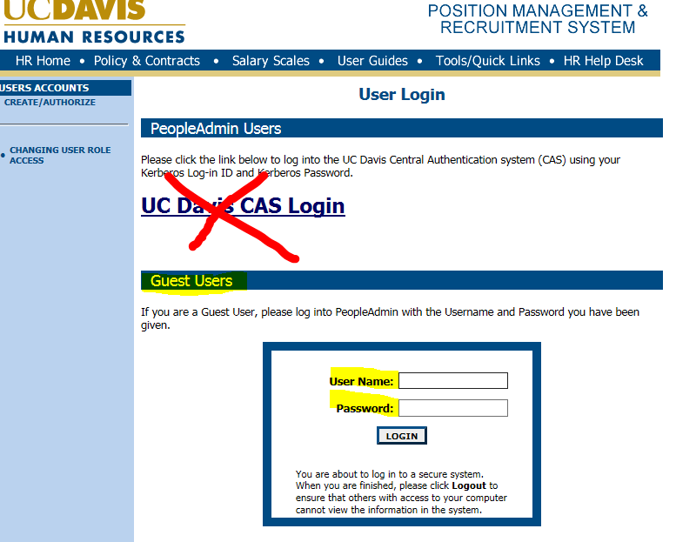

Use the User Name and Password provided by the SSO via the case notification to log in.

1. Review applicants using the  link under the applicant name. You can also review the submitted attachments in the next column: 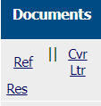. To view all, check sepcific boxes or “All” . Then you can select  or . **Please note, that to view multiple items, they will all be compiled in one document/browser page. If more than one application/document is opened, the system will lock up and log-in will be required all over again.**

**Need support?**

*Please contact the SSO HR Generalist assigned and/or the SSO Help Desk for technical issues and OCP Personnel regarding general recruitment inquiries related to guest access.*

**HOW TO PULL APPLICATIONS FROM POSITION/RECRUITMENT MANANGEMENT (PA)**

To grab applications from a guest user site do the following using **Internet Explorer only for this process**:

1. Log in to PA utilizing the Guest User Access link, ID and password provided to you.
2. Find the candidate and first click cid:image001.png@01D32275.974EACB0. This will open in a new window. Go File/Print Preview.
3. In Print Preview make the document 100% from the drop down labeled cid:image002.png@01D32275.974EACB0 at the top. Also remove the URL at the bottom by clicking the cid:image003.png@01D32275.974EACB0 icon. From there save as a PDF. CLOSE THIS WINDOW (or else the system will malfunction and you will have to log in again).
4. For any additional documents now return the guest user list of candidates and check the box in the same row for that candidate: 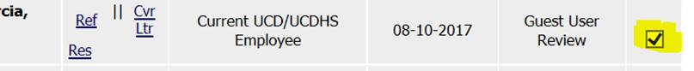
5. Now scroll to the bottom and click cid:image005.png@01D32275.974EACB0 (make sure only the 1 candidate you’d like to pull info for is checked or else this will produce all documents for all candidates checked).
6. A separate window should pop up again with a PDF save icon at the bottom cid:image006.jpg@01D32275.974EACB0. Save accordingly.
7. Combine the two files in Adobe by opening the program by itself so you see a menu and select Combine Files:

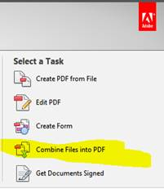

1. Combine your two files previously created and then Save As the combo accordingly**.**

**Telephone Reference Check List**

References should be checked **after** the interview and with the consent of the candidate.

**Name of Applicant___________________________________________________________**

**Person Contacted________________________________________________________­­­____ Company/Location___________________________________________________________ Telephone #/Email___________________________________________________________**

I’m calling regarding references for _____________________, who is applying for a position with _________________, at UC Davis.

**Note: Questions must be job related. Responses should be documented information.**

* Could you verify the dates of employment with you?
* What was the nature of the job (description of duties and responsibilities)? Did they have to do any analysis? How are they are navigating sensitive and difficult situations?
* If you experienced any difficulties, were they discussed with the employee? Was there improvement?
* What job progress did he/she make?
* How did he/she interact with others? How did they resolve conflict?
* What type of ambassador was this person for your department?
* How would you describe his/her performance?
* What are his/her strong and weak points?
* Could you comment on attendance, dependability, follow-through, ability to take on responsibility, initiative, degree of supervision needed, ability to learn, and any difficulties that interfered with his/her work?
* Why did he/she leave your company?
* Would you rehire him/her? If not, why not?

**INTERVIEW QUESTION BANK**

***Common Questions***

**Q**. Tell me about yourself.

**Q**. What is your greatest strength (weakness)?

**Q**. Why did you leave your last position?

**Q**. What features of your previous job have you disliked (or would you change)?

**Q**. How long would you stay with us?

**Q**. What new goals or objectives have you established recently?

**Q**. Where do you see yourself in five years?

**Q**. What can you do for us that someone else cannot?

**Q.** Why should we hire you?

**Q**. Are you analytical? Are you creative? Are you organized? Give an example.

**Q**. Can you work under pressure, deadlines, etc.?

**Q**. How do you rate yourself as an employee, professional, executive?

**Q**. Have you helped increase sales, profits, etc. and how?

**Q**. Have you helped reduce costs? How?

**Q**. What do you look for in a job?

**Q**. What kind of salary are you worth?

**Q**. How have you changed the nature of your job?

**Q**. What do you expect from the organization that hires you?

**Q**. What are your biggest accomplishments in your present job or in your career so far?

**Q**. How long would it take you to make a contribution to our firm?

**Q**. Why do you want to work for us?

**Q**. What did you do to prepare for this interview?

**Q.** What kind of working environment do you prefer?

***Questions About Weaknesses***

**Q**. Why didn't you do better in high school or college? Why haven't you found a job yet?

**Q**. If you could start again, what would you do differently?

**Q.** Do you feel you might be better off in a different size/type of organization?

**Q**. If you could change one thing about yourself, what would it be?

**Q**. How often were you late or absent in your last job?

**Q.** What did your last performance evaluation say about you?

**Q.** Are you overqualified or too experienced for this position?

Performance-Based / Behavioral Questions

**Q.** Share an example of an important personal goal that you set and explain how you accomplished it.

**Q.** Talk me through the decision-making process on a major project you've completed.

**Q.** Tell me about a time when you were given many different tasks at the same time. How did you manage these?

**Q.** Tell me about a time when you built rapport quickly with someone under difficult conditions.

**Q.** What is the most competitive work situation you have experienced? How did you handle it? What was the result?

**Q.** Describe a situation in which you were able to effectively "read" another person and guide your actions by your understanding of their individual needs or values.

**Q.** What kind of decisions do you make rapidly? What kind take more time? Give examples.

**Q.** When you have difficulty persuading someone to your point of view, what do you do? Give an example.

**Q.** Give me an example of when you had to go above and beyond the call of duty in order to get the job done.

**Q.** Tell me about the most difficult or frustrating individual that you've ever had to work with, and how you managed to work with them.

**Q.** Tell me about a problem that you solved in a unique or unusual way. What was the outcome? Were you satisfied with it?

**Q.** Tell me about a specific time when you had to handle a tough problem which challenged fairness or ethical issues.

**Q.** Give an example of a time in which you felt you were able to build motivation in your co-workers or subordinates at work.

***Technology***

**Q.** What programming languages are you proficient in?

**Q.** What operating systems do you have experience with?

**Q.** Tell me about your most recent technical project.

**Q.** What was the most difficult software project you were involved in?

**Q.** What would be your language of choice for implementing CGI programs on a web server and why?

**Q.** How do you balance between time spent testing a product and getting to market?

**Q.** What are the advantages and disadvantages of DHCP?

**Q.** Why does C/C++ give better run-time performance than Java?

**Q.** What is HTTP and how does it work in basic terms?

**Q.** Provide a basic explanation of a database in three sentences or less.

**Q.** What is the difference between data warehousing and data mining?

**Q.** This position requires a lot of technical knowledge. How did you obtain your technical skills and how long did it take?

**Q.** What are some of the commonly used techniques to optimize code?

**Q.** What are the differences between Mac, Windows and UNIX?

**Q.** Compare and contrast C++ and Java.

**Q.** What are transient variables in Java?

**Q.** What web servers do you have experience with? Apache? IIS?

**Q.** Describe your most recent web development project.

***Customer Service***

**Q.** Tell me about a time when you handled a dispute with a customer or co-worker. How did you deal with it?

**Q.** Tell me about a time when you displayed excellent customer service.

**Q.** Give me an example of a time when you initiated a change in process or operations in response to customer feedback.

**Q.** What personality trait of yours do you find most valuable when dealing with customers?

**Q.** How do you establish rapport with a customer?

**Q.** Describe a situation where you went above and beyond the call of duty to accommodate a customer.

**Q.** How do you respond to rude or abusive customers?

**Q.** What motivates you to work in the customer service field?

**Q.** What is the most important customer service skill that you need to have in your daily activities?

**Q.** How do you build positive relationships with your customers?

**Q.** Describe your typical customer base.

**Q.** Give an example of a stressful interaction you had with a customer and how you reacted.

***Education***

**Q.** How have and will you address your students' different learning styles?

**Q.** What steps would you follow to deal with a student who displays consistent behavioral problems?

**Q.** How would you handle difficult parents?

**Q.** Describe your teaching style.

**Q.** When did you decide to pursue education, and why did you choose this field?

**Q.** What is the most difficult aspect of education today?

**Q.** How do you motivate students to become active learners or how do you encourage class participation?

**Q.** Tell me about a troubling student you have taught and how you helped him or her.

**Q.** Describe an ideal curriculum in your area of study.

***Engineering / Design***

**Q.** What software/engineering/design skills have you developed or improved upon during the past year?

**Q.** Which software packages are you familiar with? What is the most interesting thing you know how to do with one of these packages?

**Q.** What are you doing to stay up-to-date with the latest technology?

**Q.** Describe for me an innovative technical solution you recently developed.

**Q.** Tell me about how you would develop and manufacture a new birdhouse.

**Q.** Thinking of a specific engineering or design project you've been involved in, tell me what could you have done to be more successful in achieving your goal(s)?

**Q.** Some of the best-engineered ideas are born out of an individual's ability to challenge others' ways of thinking. Tell me about a time when you did this successfully.

**Q.** If you had a chance, what product would you improve and why?